**Digicomp Data Analysis by Microsoft Power BI**

I conducted a data analysis project on Digicomp sale data

Tools Used – Microsoft Power BI

**Data Collection:**

* **Identify Data Sources:** Determine where this data is coming from.
* **Raw Data:** Collect the data. Ensure it is complete and includes all relevant fields for this analysis.

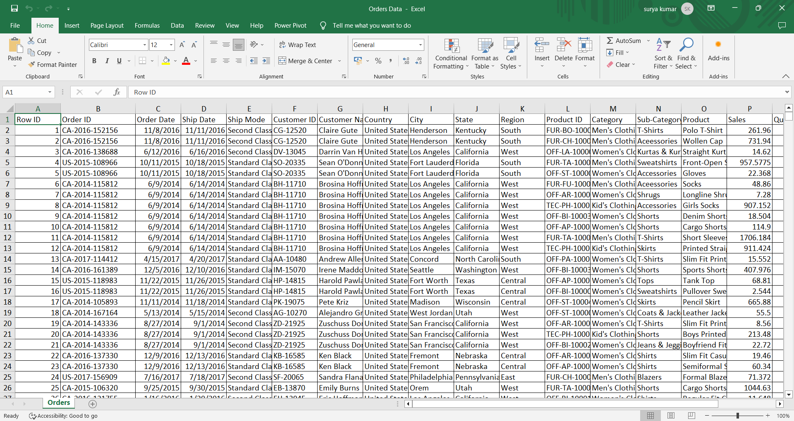

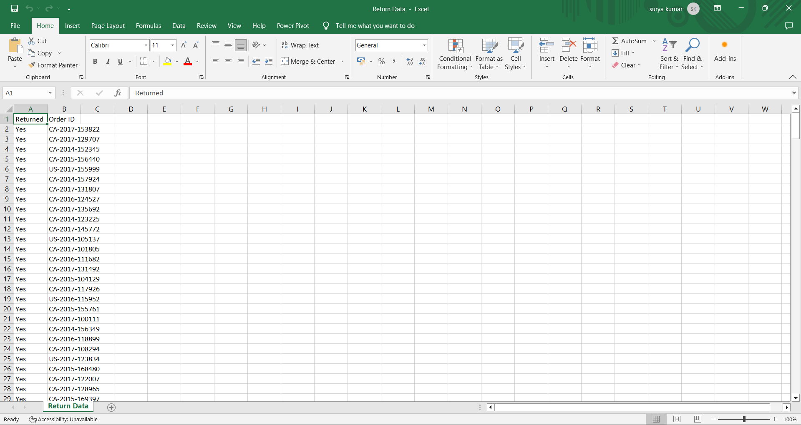

**Import Data into PowerBI:**

* Launch Power BI Desktop.
* Data Source Connection: Click on "Get Data" to connect to the data source. Choose CSV file ).
* Load the data into Power BI.

**Data Modelling:**

* Design the data model by creating relationships between tables (Order data and Return data) and define measures and calculated columns for calculations.

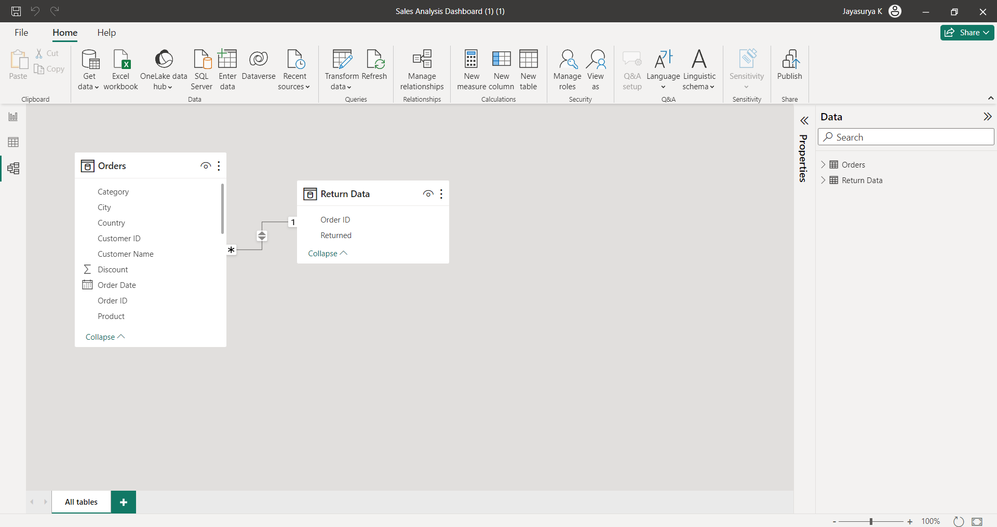

**Data Cleaning:**

* Remove duplicates, handle missing values, and correct any errors and inconsistencies in the dataset.

**Data Exploration:**

* Build the visuals to explore the data. Drag and drop fields onto the report canvas to create charts, tables, and graphs.
* Add filters and slicers to allow users to interactively explore the data.

**Data Analysis:**

* Use the DAX (Data Analysis Expressions) to create calculated measures for more advanced analysis. Calculate metrics like growth rates, averages, and ratios.
* Design KPI cards to highlight critical metrics and track performance against targets.

**Data Visualization:**

* Create various types of visualizations like bar charts, line charts, pie charts, and maps to represent the insights effectively.
* Combine multiple visuals into a cohesive dashboard for a comprehensive view of the data

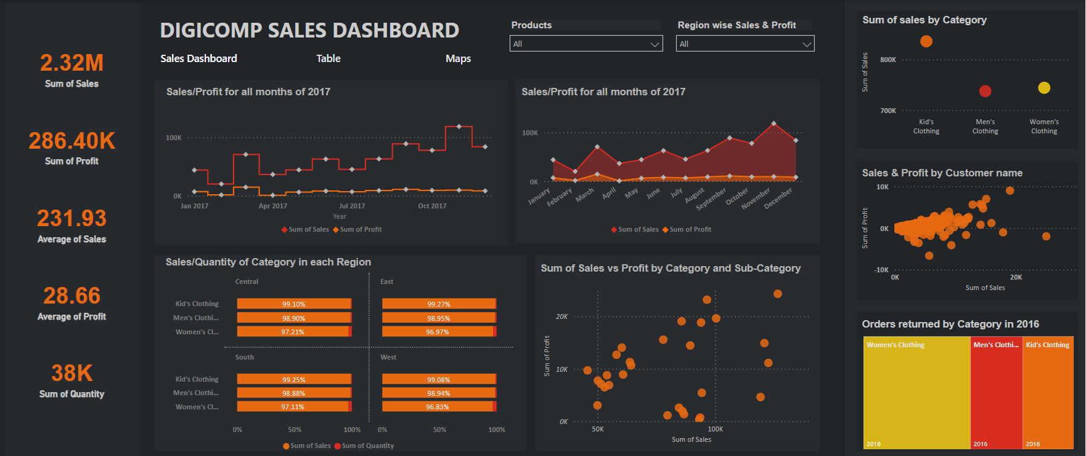

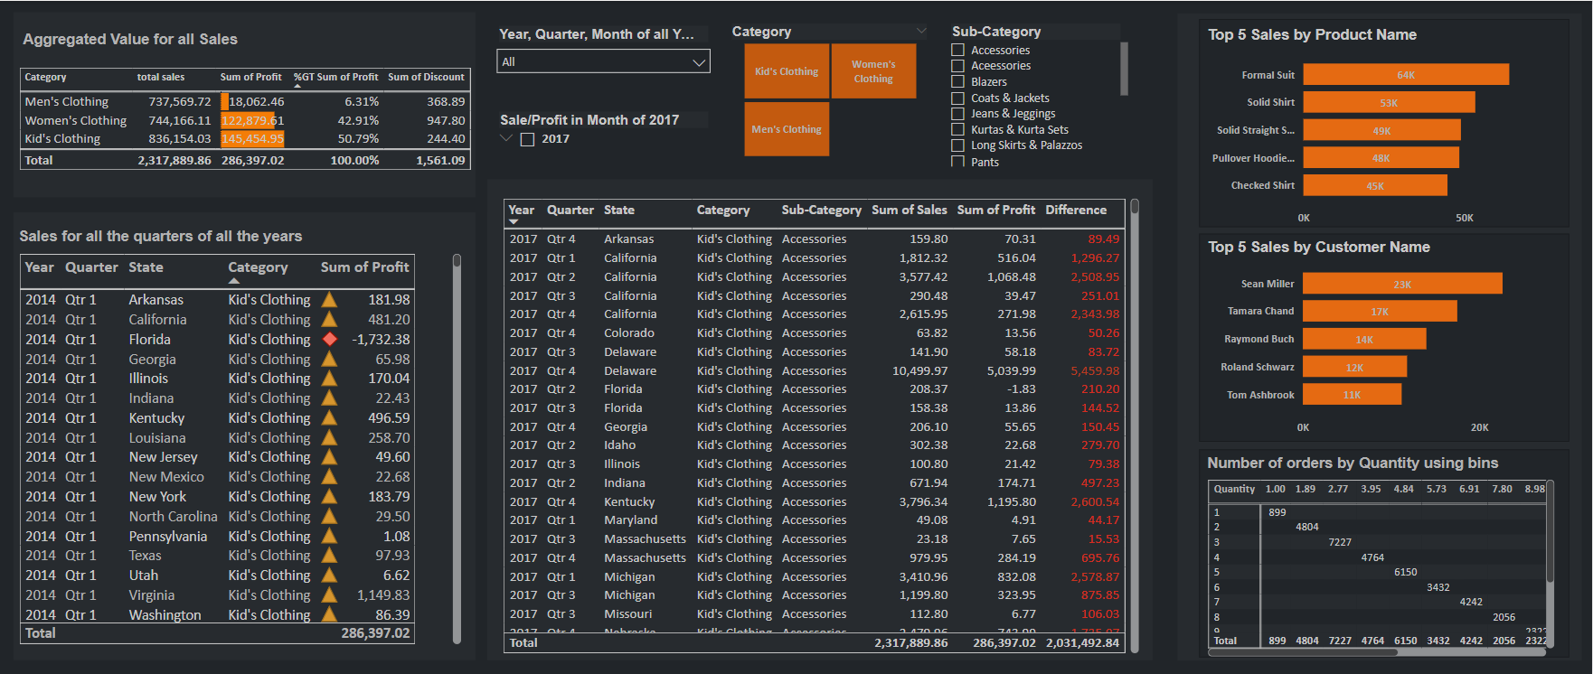

**Insights:**

* Sales/Profit for all months of 2017
* Sales/Quantity of Category in each Region
* Sum of Sales vs Profit by Category and Sub-Category
* Sum of sales by Category
* Sales & Profit by Customer name
* Orders returned by Category in 2016
* Top 5 Sales by Product Name
* Top 5 Sales by Customer Name
* Aggregated Value for all Sales
* Sales for all the quarters of all the years
* Sum of Sale by State